

Meeting Dates and Times

**Jul 2 at 2-3:30PM – BOARD Meeting at BGC**

**Jul 9 at 4-5:30PM – General Meeting at BGC**

**August OFF**

**Sep 3 at 2-3:30PM – BOARD Meeting at BGC**

**Sep 10 at 4-5:30PM – General Meeting at BGC**

**Oct 1 at 2-3:30PM – BOARD Meeting at BGC**

**Oct 8 at 4-5:30PM – General Meeting at BGC**

**Nov 5 at 2-3:30PM – BOARD Meeting at BGC**

**Nov 12 at 4-5:30PM – General Meeting at BGC**

**Dec 3 at 2-3:30PM – BOARD Meeting at BGC**

**Dec 10 at 4-5:30PM – General Meeting at BGC**

**\*See Chat and Chew section for date/details**.



**General Meeting**

At our July 9 meeting at 5 PM at BGC, Chad Merrill will give a presentation on meteorology. Dinner at 6 PM will be pizza and salad. If you would like dinner, please contact Claudette Lease at claudette1944@hotmail.com to make a reservation. The cost is $15. No reservations will be accepted after July 6 so please reserve early.

**AUGUST MEETING** - There will be no chapter meetings in August. In September, we’ll have our next general meeting on the 10th when Mary Hoferek will talk about her trip to Antarctica.

**Board Volunteers**

****We need some help on the Board. The Board meets the first Tuesday of the month at 2 PM for about an hour at BGC. In particular, we need a secretary and a service project lead. The secretary will take the minutes and draft letters as needed (not often). The service project lead will contact recipients to find out what they need and organize the effort. If you can help, please contact Robert Stone at [stoner9599@verizon.net](mailto:stoner9599@verizon.net) and Mary Hoferek at [mary.hoferek@gmail.com](mailto:mary.hoferek@gmail.com).

**Food Collection**

It was heartwarming to see all the food we collected for the Gaithersburg Cares Hub. Not only were our hearts full; Charlyn’s office was too. It was great for our chapter to partner with the Benjamin Gaither Center and work together on this effort. Thank you to the center and to all of you who contributed so generously.

**Here’s a message from the CaresHub:**

Hello everyone,

I just wanted to take a moment and thank you for your support through your recent food drive. We received 450 lbs of food that will continue to keep our food pantry's shelves stocked. (In addition, we donated $225.) We are grateful for your collaboration and for being such amazing neighbors as we work together to create a city where everyone thrives!

Thanks again,

Lindsay

**Advocacy Team**

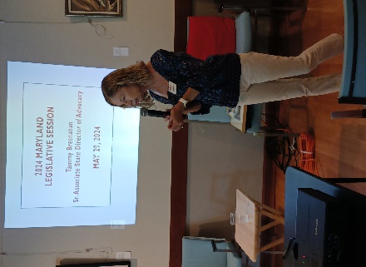Our thanks to Karen Kalla who spoke with us about the state Legislative Advocacy Team at our June meeting. They were very successful in helping pass laws to support seniors in Maryland. In particular, Senate Bill #1 (utility) and Senate Bill #202 (caregivers) were highlights.

**Chat and Chew**

Our chat and chew will be on July 16 at 1 PM at Hershey’s (17030 Oakmont Avenue. Gaithersburg, MD 20877). Please contact Nancy Dols at nancydols17@gmail.com so she can make the reservation.

**School Supply Service Projects**

 Our next service project is school supplies. Every year we have donated items like pencils, crayons, etc to one or two local Title 1 schools. This year we are going to help Brown Station Elementary and Gaithersburg Elementary. We expect to deliver the items by August 1. We need volunteers who can buy the items. We have allocated $300 for each school from the chapter budget. If you can help with this effort, please let Mary Hoferek (Brown Station) or Claudette Lease (Gaithersburg) know.

Join us on Facebook

You can always find us online at **Facebook**:   
[AARP Chapter #5358 Gaithersburg 2016](https://www.facebook.com/groups/154323637923385/)

This Month’s Birthdays

**Let’s celebrate & wish the following a happy birthday!**

Laura Loomis – Jul 8

Annette Thompson – Jul 19

Dorothy Kuzminski – Jul 23

Claudia Herbert – Aug 3

Betty Tobiassen – Aug 6

Kathleen Bell – Aug 14

Martha Levin – Aug 26

Nancy Dois – Aug 27

Margery Prentice – Aug 31

**Juneteenth Celebration**

Our state AARP was a proud sponsor of the Juneteenth celebration this year.